STEM DAY SCHEDULE QUARTER 1

8:00-9:00 INTRODUCTION:
What is a meteorologist? (Show weather clips from wsbtv, cbs, nbc, weather channel, etc… so students can get a better understanding of what a meteorologist does)
http://www.wsbtv.com/s/weather/
http://www.11alive.com/story/weather/2014/03/04/atlanta-area-local-weather-forecast/6020515/
https://www.youtube.com/watch?v=lm-QxxWTwYQ

Here is a great (and short) video of a young student from the show ZOOM! http://www.pbslearningmedia.org/resource/ess05.sci.ess.watcyc.kidmeteor/kid-meteorologist/
_____________________________________________________________________________________
Create Meteorologist class poster. (See example below)
What does a meteorologist do? (on chart paper or smartboard)
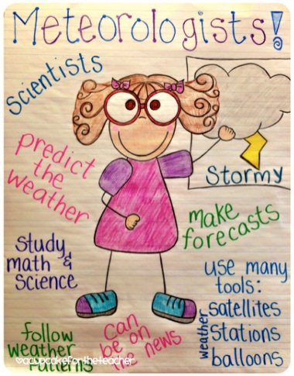

_____________________________________________________________________________________
What are the different types of weather? Create graphic organizer on smartboard or chart paper
http://www.sciencekids.co.nz/videos/weather.html

Weather Graphing Activity (emailed with other weather resources & attached to hard copy)
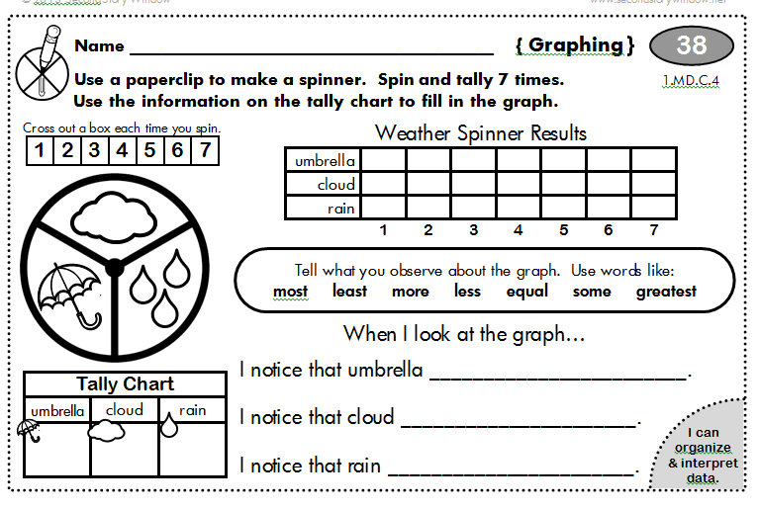
_____________________________________________________________________________________
9:00-9:25: SNACK, Brain Break, Games on SmartBoard
Cat in the Hat Weather Transformer Game
http://pbskids.org/catinthehat/games/weather-transformer.html
Sid the Science Kid - sort plants, animals, etc. into the correct environment based on temperature
http://pbskids.org/sid/fablab_weathersurprise.html

EdHeads Report The Weather Game:
http://www.edheads.org/activities/weather/frame_loader.htm
Scholastic Weather Transformation Game:
http://www.scholastic.com/kids/weather/sim/game.htm
9:25- 9:45
Introduce weather tools: PowerPoint Presentation
T:\Teachers\first grade\STEM\STEM Weather
Create weather tools book (Click link below; Also attached smaller version to hard copy)
Weather Tools Book

9:45-10:35
Begin to Follow STEM Lesson Plan
http://brumbystem.weebly.com/quarter-1.html
Be sure that they design, create, test, retest and improve.
Guide discussions about what is working, what went wrong, and ideas for improvement.

10:35-11:35
Lunch & Bathroom Breaks

11:35-12:15
Continue to Follow STEM Lesson Plan
Be sure that they design, create, test, retest and improve.
Guide discussions about what is working, what went wrong, and ideas for improvement.
12:15-1:00
Create Weather Reporting Videos :)

