Lesson Title: Squeezing Water from Fog
Grade Level: 4th | Quarter: 1st
Standards:
Science:
S4E3a States of Matter (Water)
Demonstrate how water changes states from solid (ice) to liquid (water) to gas (water vapor/steam) and changes from gas to liquid to solid.
S4E3d Water Cycle
Explain the water cycle (evaporation, condensation, and precipitation).

ELA:
ELACC4SL1 Engage effectively in a range of collaborative discussions (one-on-one, in groups, and teacher-led) with diverse partners on grade 4 topics and texts, building on others’ ideas and expressing their own clearly.

Math:
MCC.4.MD.2 Use the four operations to solve word problems involving distances intervals of time, liquid volumes, masses of objects, and money including problems involving simple fractions or decimals and problems that require expressing measurements given in a larger unit in terms of a smaller unit. Represent measurement quantities using diagrams such as number line diagrams that feature a measurement scale.

MCC4.MD.4 Make a line plot to display a data set of measurements in fractions of a unit (1/2, ¼, 1/8). Solve problems involving addition and subtraction of fractions by using information presented in line plots. For example, from a line plot find and interpret the difference in length between the longest and shortest specimens in an insect collection.

Lesson Essential Question:  - How can we use our knowledge of the water cycle to help us engineer a solution to a real-life problem?  - How can we collect water from clouds?  - How can I measure the collected water from clouds?  - How can I make a line plot displaying class data? | Vocabulary:  Water cycle  Solid  Liquid  Gas  Fog  Evaporation  Condensation  Precipitation
Lesson Materials:  A Cool Drink of Water, Barbara Kelly (ISBN 0-7922-5489-9)  Down the Drain: Conserving Water, Anita Ganeri and Chris Oxlade (ISBN 978-1-4034-6845-1)  -Pipe Cleaners  -Wooden Dowels/Metal Coat Hangers  -Plastic Buckets, plastic milk jugs, coffee cans or other large plastic containers  -Used panty hose  -Netting or other loosely woven fabric  -Masking tape  -Craft Sticks  -Wax paper  -Plastic wrap  -Duct Tape  -Glue  -Ruler/Meter Stick  -Measuring Cups  -Stop Watch  Vaporizer/Humidifier (borrow from a parent or science teacher; also available at drugstores for about $30) | Lesson Assessment:  Completed product  Written Student Journals  Class graphs  Student Participation
STEM Challenge Overview:

Students will use their knowledge of the water cycle and the states of water to engineer a device which will collect water from clouds?

Teacher Background:

This activity requires the use of a vaporizer/humidifier. While these can be purchased relatively inexpensively at drugstores, it is often possible to find used ones at garage sales, to borrow one from a parent with small children, or the science teacher.

This activity should take place after students have had an initial introduction to the water cycle and its 3 states (solid, liquid, gas) and a condensation experiment/demonstration has been performed.

Decide ahead of time how to structure the groups, ideally of 4 students each. Should jobs be assigned or should students decide job assignments among themselves?

After the reading “hook”, students will work in collaborative groups to create a device which can draw water from “fog”. The fog will be created by the vaporizer/humidifier.

Success of the device will be determined by whether it extracts water from the fog.

Extracted water will be measured.

The class will create a line plot which shows how much water was extracted by each device.

INSTRUCTION
- Ask/Engage - Day 1 – 45 min.
Hook question: Ask students: “What do you like to drink when you’re really thirsty?” Show students a real glass of ice water or a picture (attached).

Use the document camera to read A Cool Drink of Water, by Barbara Kerley. The text is very simple and it will be a quick read. The focus is near the end of the book “A Cool Drink Around the World”, which shows a number of snapshots with captions which deal with the different ways people around the world collect water.

Briefly discuss the many different ways there are of collecting water. Then read “A Note on Water Conservation”, at the back of the book, again using the document camera so students will be able to read along; emphasize that 97% of Earth’s water is saltwater and of the 3% left that is freshwater, 2/3 of it is tied up in polar ice and glaciers. Tell the students that as the population increases, there is even less freshwater available for people to use.

Tell students that they will be exploring a way to get more fresh water for people in countries that do not have enough fresh water.

Use the interactive whiteboard to show the following website to the class. A Peace Corps member wrote it about the impoverished African country, Cape Verde, to which he was assigned.
http://www.peacecorps.gov/wws/stories/source-our-water-cape-verde/

Tell the students that Cape Verde needs access to more fresh water. They live on islands off the coast of the Africa and there is a lot of fog that collects in the mountain regions of their country. Fog is a low-lying cloud, and since clouds are made of water vapor, is there a way to collect water from the fog?

Tell students that their STEM challenge is to engineer an inexpensive way to harvest water from the fog.
Challenge:
97% of the Earth’s water is saltwater; of the 3% that is left, 2/3 of that water is trapped in glaciers and polar ice. How can areas which don’t have enough water get more water from low-lying clouds, also known as fog? How can we use our knowledge of the water cycle and the states of water to engineer an inexpensive device which will collect water from clouds?

- Imagine/Brainstorm – Day 2 – 45 min.
Tell the students that they will be working in groups to design a water harvester. Since the people in Cape Verde have very little money, it would be helpful if the water harvester could be constructed from easily available, inexpensive materials. Therefore, the water harvester must be constructed from the materials which the teacher has provided.
Criteria:
1. Must have water collection reservoir
2. Must be sturdy to withstand repeated use
3. Device will be exposed to “fog” for 2 min. Water in collection reservoir will be measured using a measuring cup
4. Device will be “successful” if it collects water
5. Most successful device will be the one which collects the most water
6. Create a line plot displaying the class data one the device that collects the most water.
Constraints:
1. No taller than 60 cm; no wider than 46 cm
2. Must be made from available materials

Thinking partners or elbow partners should briefly discuss what they know about the water cycle, especially how condensation works, before getting started on independent design solutions.

Each student should work independently on 1 or 2 possible design solutions. Designs should be labeled and indicate materials and quantities that will be needed to build the device.

- Plan/Design – Day 3 – 45 min.
Ideally, teams should consist of 4 persons: team manager/spokesperson, plan designer, materials manager and timekeeper/measurement technician. All students will be responsible for helping to build and test the device. Each student will be responsible for thoughtful completion of his/her Student Journal.

Each student will present his/her ideas to the team.

Student teams will collaborate to come up with a final design plan that is agreeable to all of them. If the group can’t reach a consensus, then the team manager will make the final choice. Clear communication will be essential as the team works to draw the plan, create a materials list based on the plan, and assign tasks for building the collection device.

- Create / Test – Day 4 – 45 min.
Teams will build their design according to their design plan. Each student should be involved in the building process.
Upon completion of the harvesting device, teams will test their device and record the necessary data in their individual journals and on the class graph.

- Evaluate/Improve – and repeat Steps 1-5 – Day 5 – 30 min.
Each group will evaluate their water harvester, both verbally and in the Student Journals. Was it successful? Did it meet the criteria? Did the final design match the planned design? What changed? Why did it change?

The whole class will review the data according to the class graph: which harvesting device was most successful? Why was it the most successful? Discuss and share thinking about ways to improve the harvesters. Record this information at the bottom of the class line plot.

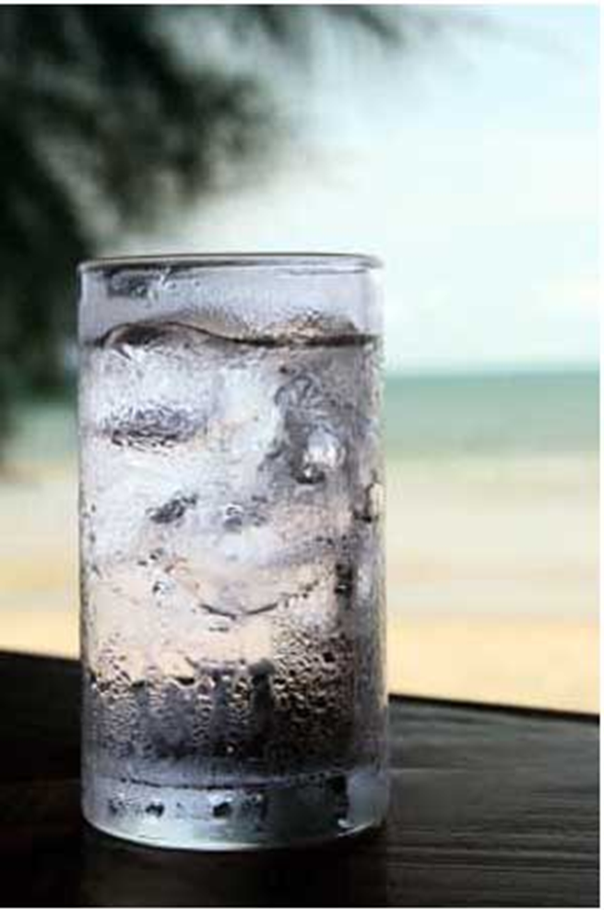

Name:___________________

Squeezing Water from Fog
4th Grade STEM Challenge

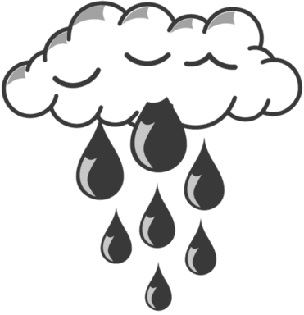
Challenge: 97% of the Earth’s water is saltwater; of the 3% that is left, 2/3 of that water is trapped in glaciers and polar ice. How can areas which don’t have enough water get more water from low-lying clouds, also known as fog? How can we use our knowledge of the water cycle and the states of water to engineer an inexpensive device which will collect water from clouds?
Criteria:
1. Must have water collection reservoir
2. Must be sturdy to withstand repeated use
3. Device will be exposed to “fog” for 2 min. Water in collection reservoir will be measured using a measuring cup
4. Device will be “successful” if it collects water
5. Most successful device will be the one which collects the most water
6. Create a line plot displaying the class data one the device that collects the most water.
Constraints:
1. No taller than 60 cm; no wider than 46 cm
2. Must be made from available materials
Materials:

Pipe Cleaners
Wooden Dowels
Craft Sticks
Netting or loosely woven fabric
Old Panty Hose
Metal Coat Hangers
Coffee Cans or large metal containers
Large Plastic Containers or milk jugs

Duct Tape
Glue
Measuring instruments: meter stick, measuring cups; stopwatch
Wax paper
Plastic wrap

- ASK / ENGAGE: What is the problem you are being asked to solve?
________________________________________________________________________________________________________________________________________________________________________________________________________________________________________________________________________________________________________________________________________________________________________________________________________
- IMAGINE/BRAINSTORM: What are some possible solutions to the problem that you are trying to solve? After you brainstorm, draw and label your ideas below.
Idea #1 | Idea #2
- PLAN/DESIGN: Share your ideas with your group and collaborate to decide on a final design plan. Draw your team’s design below and make a list of the materials that you will need to complete your design.
Team Design Plan | Materials List

- CREATE/TEST: Use your Final Design Plan to create and build your solution. Test your design. Did it work? Why or Why not?
Record the amount of water your device harvested from the “fog”.
____________________________________________________________________________________________________________________________________________________________________________________________________________________________________________________________________________________________________________________________________________________________________________________
- EVAULATE/IMPROVE: How well did your design work? Did your solution solve the problem within the given constraints?
____________________________________________________________________________________________________________________________________________________________________________________________________________________________________________________________________________________________________________________________________________________________________________________________________________________________________________________________________________________________________________________________________________________________________________________________________________________________________________
How can you improve your design? How can you make it better? Draw and label your improved design below.
Improved Design Plan

