|  |  |
| --- | --- |
| **Plant It!**  **C:\Users\sse11532\AppData\Local\Microsoft\Windows\Temporary Internet Files\Content.IE5\OVQZIEL9\MC900183052[1].wmf** | |
| **Background Information** | |
| You have been learning about plants. You have learned how to group them by what their appearance, size, and color is. You even know how to explain why they are different! Today you will begin a new plant challenge!   * This challenge was designed based off of “Growing Plants” that can be found at: <http://www.childrensengineering.com/DB-GrowingPlants.pdf> | |
| **Design Challenge** | |
| Home Depot is looking for a new way of organizing plants in a garden. They know that you have been learning all about grouping plants and need your expert help! They would like you to create a garden based upon different pictures of plants they have provided for you. Your job will be to work in a group of 3 to 4 students to create your very own garden. Your garden must be organized based upon appearance, size, and color. Each group member must create 3 plants each and figure out a way to make their plant free standing. Have fun and get your green thumb ready! | |
| **Criteria** | |
| Your garden must:   * Have 3 different types of plants * Each student must make 1 of each type of plant * Your plants in your garden must stay standing * Your garden needs to be organized by one of the following: appearance, size, or color | |
| **Materials/Tools:** | |
| * construction paper * craft sticks * toilet paper or paper towel rolls * pipe cleaners * glue * brass fasteners | * empty plastic bottles * Styrofoam cups/coolers * Cardstock * Scotch tape or masking * string/yarn |
| **Standards** | |
| **Science**  SKL1. Students will sort living organisms and non-living materials into groups by observable physical attributes.   * c. Group plants according to their observable features such as appearance, size, etc.   SKL2. Students will compare the similarities and differences in groups of organisms.   * b. Explain the similarities and differences in plants. (color, size, appearance, etc.) | |
| **Assessments/Rubrics** | |
| * Student Journals * Student Checklist * Teacher Observation | |

**Plant Pictures**

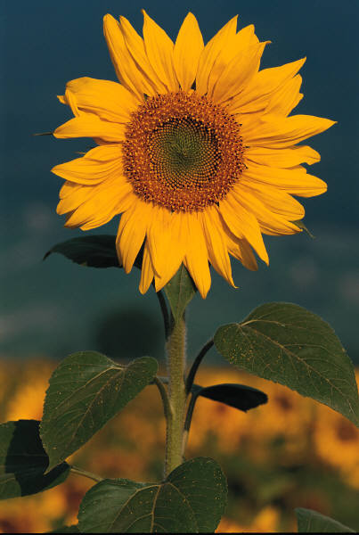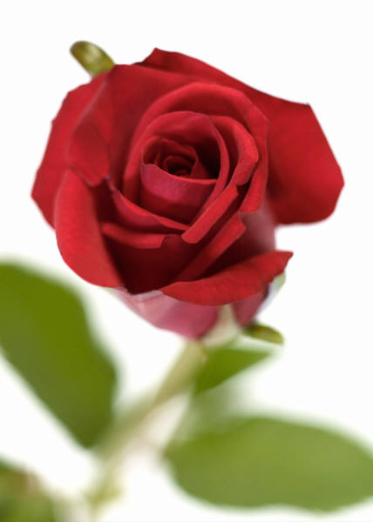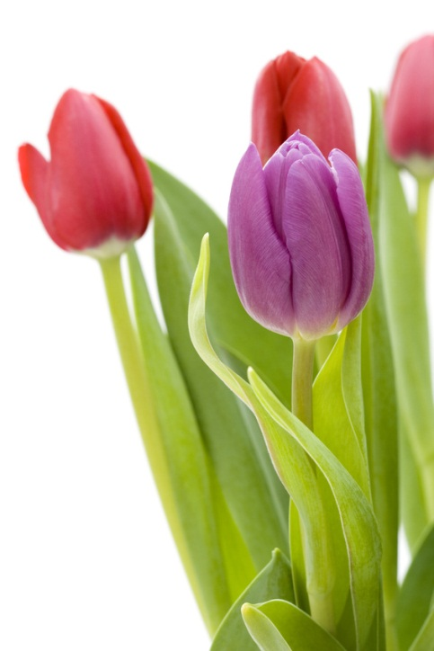

**C:\Users\sse11532\AppData\Local\Microsoft\Windows\Temporary Internet Files\Content.IE5\OVQZIEL9\MC900183052[1].wmfPlant It!**

**Student Journal**

Name_______________________________________ Date_________________________

1. ASK: What is the problem? 

* State the problem in words.

|  |
| --- |
|  |
|  |
|  |

|  |
| --- |
|  |

OR draw a picture of the problem and label it.

1. C:\Users\sse11532\AppData\Local\Microsoft\Windows\Temporary Internet Files\Content.IE5\USN4D55T\MC900441880[1].wmfBRAINSTORM Possibilities

* What do you already know that will help you solve this problem?
* Think about the constraints of this challenge.
* Sketch or describe some possible solutions.
* Be sure to add labels to your design.

|  |  |
| --- | --- |
|  |  |

1. CREATE the solution that you think is best. Share your ideas with your group and decide which design is the best possible solution to the problem.

* Write down your design plan step-by-step.

|  |
| --- |
|  |
|  |
|  |
| 4. |

* List or draw the materials that you will need to complete your design.
* _____________________________________
* _____________________________________
* _____________________________________

|  |
| --- |
|  |

1. DRAW and label your final design.

|  |
| --- |
|  |

1. EVALUATE your solution.
   1. Test your design
   2. Record your results
   3. Did your design solve the problem?

____________________________________________________________________________________________________________________________________________________________________________________________________________________________________________________________________________________

|  |
| --- |
|  |

Circle your answer.

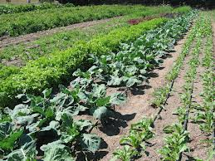Did your group organize the garden by size, color, or appearance? YES NO

**C:\Users\sse11532\AppData\Local\Microsoft\Windows\Temporary Internet Files\Content.IE5\USN4D55T\MC900391454[1].wmf**Did all of your group’s plants stay standing? YES NO

C:\Users\sse11532\AppData\Local\Microsoft\Windows\Temporary Internet Files\Content.IE5\SEDMZEHV\MC900014089[1].wmf Did all group members create 3 plants? YES NO

* How could you improve your design?
* What could you do differently next time? Draw or write

|  |
| --- |
|  |

_______________________________________________________________________________________________________________________________________________________________________________________________________________